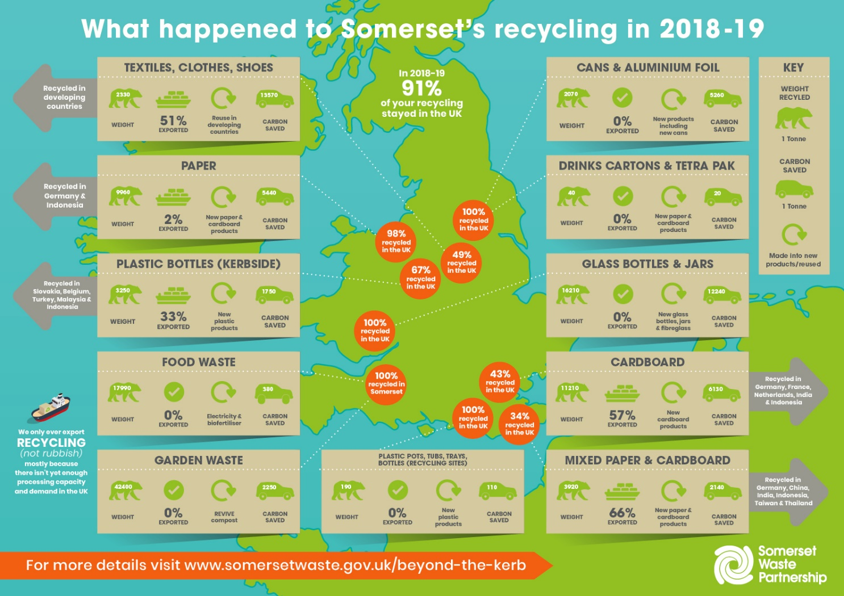

**Where does all your recycling go?**

The latest edition of the pioneering report, [“Beyond the Kerb – Recycling to Resources”](https://www.somersetwaste.gov.uk/beyond-the-kerb/), shows how every tonne of Somerset’s recycling has contributed to cutting all our carbon footprints.

In 2008, SWP was the first in the UK to publish detailed information every year on what happens to your recycling. Many others have followed that lead.

For the first time SWP has [turned this information into an infographic](https://www.somersetwaste.gov.uk/wp-content/uploads/2019/12/SWP_IG_Map_UPDATE_WEB.jpg) – see above – helping to get the message out to more people that sorting your recycling produces high quality material streams that can be kept in the UK and maximise our carbon savings.

Thanks to residents and recycling crews separating recycling, over half stays in Somerset and over 90% stays in the UK.

Somerset is independently ranked as the seventh-best area in England for carbon saving, equivalent to taking more than 25,000 cars off the road for a year.

The full “Beyond the Kerb – Recycling to Resources” report tracks the destination of the 133,734 tonnes collected in 2018-19 for recycling and reuse, including everything from cans to clothes, with the amounts, locations and companies, and the carbon saved by recycling.

Transparency is important to SWP because, to tackle climate change, it is important not just how much we recycle, but how we recycle it.

The recycling that stays in Somerset includes all 17,990 tonnes of food waste – turned into electricity and farm compost at the anaerobic digestion plant near Bridgwater – and all 42,400 tonnes of garden waste.

In 2018-19, Somerset did not send abroad for reprocessing a single glass bottle or jar, steel or aluminium can, aerosol, Tetra Pak or other beverage carton. All cooking oil, engine oil and all the 172 tonnes of water-based paint sent for reuse stayed in the UK.

Reprocessed in the UK, most of Somerset’s glass was turned back into new glass bottles and jars – saving over 12,000 tonnes of carbon.

Millions of plastic pots, tubs and trays taken at every recycling site also stayed in the UK to become the raw materials for new products and packaging in plants across the country from Kent to Yorkshire, Wales to Manchester.

Due to the lack of UK reprocessing capacity or demand, SWP’s collection and recycling site contractors send a proportion of some materials overseas. Every tonne is carefully tracked.

In all, what goes abroad for reprocessing is just 9% of Somerset’s recycling. For example, to meet demand in the developing world, just over half of Somerset’s recycled textiles, clothes and shoes went overseas for sale and reuse.

And to make new packaging for the white goods and electronics we import, a proportion of Somerset’s paper and card was exported for reprocessing.

The only plastics exported were a third of the plastic bottles from kerbside collections – the most valuable plastics so too good to be dumped – that went to legitimate companies in Belgium, Indonesia, Malaysia, Slovakia and Turkey to become more plastic packaging.

A Somerset Waste Partnership spokesman said: “We’re proud of what we achieved and take care to track every tonne of recycling, but we want to do even better in the future.

“As new recycling capacity comes on line in the UK – including the country’s largest plastics plant in Avonmouth, powered by burning Somerset’s rubbish – even more can be achieved.

“If there is enough UK capacity and demand, from spring 2020 we won’t export anything we collect kerbside.”

Check out [the full report here](https://www.somersetwaste.gov.uk/beyond-the-kerb/).

And [download the infographic here](https://www.somersetwaste.gov.uk/wp-content/uploads/2019/12/SWP_IG_Map_UPDATE_WEB.jpg).